YAşAR UNIVERSITY
GRADUATE SCHOOL
MASTER/PHD/PROFICIENCY IN ART THESIS

TITLE OF THE THESIS
second lıne of the tıtle
thırd lıne of the tıtle

Full name
Thesis Advisor: ASSISt./Assoc./prof.(PhD) xxx yyy
Co-advisor: ASSISt./Assoc./prof.(PhD) xxx yyy (if exısts)

name of the PROGRAMME

Presentation Date: XX.XX.20XX
We certify that, as the jury, we have read this thesis and that in our opinion it is fully adequate, in scope and in quality, as a thesis for the degree of Master of Science /Master of Arts/ the Doctor of Philosophy/Proficiency in Art.
Jury Members: | Signature:
Assist./Assoc./Prof.(PhD) Xxx YYY  … University | .......................
Assist./Assoc./Prof.(PhD) Xxx YYY  … University | .......................
Assist./Assoc./Prof.(PhD) Xxx YYY  … University | .....................
Assist./Assoc./Prof.(PhD) Xxx YYY  … University | .....................
Assist./Assoc./Prof.(PhD) Xxx YYY  … University | .....................
Assist./Assoc./Prof.(PhD) Xxx YYY  … University | .....................

-----------------------------------------------------------------
Prof. (PhD) Yucel Ozturkoglu
Director of the Graduate School

ABSTRACT
title of the thesis
Family Name, First Name
MA/MSc/PHD/Proficiency in Art, Name of the Programme
Advisor: Assist. /Assoc./Prof. (PhD) Xxx YYY
Co-Advisor: Assist./Assoc./Prof.(PhD) Xxx YYY
Month 20XX
In the study of stochastic models of production and service systems, analytical results are quite often validated by simulation studies. This study calls into question the ontological aspects, let alone the validity, of simulation. This thesis investigates the claim and its implications, and finally brings a resolution to the seemingly paradoxical practice, which has been entrenched in the dominant paradigms of operations research. In doing so, the thesis contributes to the state of the art by providing additional insights and a deeper understanding.
keywords: structure of scientific revolution, system's view, paradoxes, production and service systems, simulation, stochastic models

ÖZ
türkçe başlık
Soyad, İsim
Yüksek Lisans / Doktora Tezi, Program Adı
Danışman: Dr.Öğr.Üyesi/Doç./Prof. Dr. Xxx YYY
Yardımcı Danışman: Dr.Öğr.Üyesi/Doç./Prof. Dr. Xxx YYY
Ay 20XX
Üretim ve servis sistemlerinde kullanılan rassal modellerin analitik çözümleri genellikle benzetim çalışmalarıyla doğrulanmaktadır. Bu çalışma benzetimin ontolojik açıdan doğruluğunu sorgulamaktadır. Paradoksal görünümüne rağmen benzetimin neden ve hangi durumlarda başarılı olduğu ve hangi durumlarda da bir geçerleme yöntemi olarak yetersiz olduğu saptanmıştır.
Anahtar Kelimeler: benzetim, servis sistemleri, üretim sistemleri, rassal modeller, sistem bakışı

ACKNOWLEDGEMENTS
(This part will be blank in the submission of the thesis for the thesis defense. It will be added on the final submission)
Full Name
İzmir, 20XX

TEXT OF OATH
I declare and honestly confirm that my study, titled “THESIS TITLE” and presented as a Master’s/PhD Thesis, has been written without applying to any assistance inconsistent with scientific ethics and traditions. I declare, to the best of my knowledge and belief, that all content and ideas drawn directly or indirectly from external sources are indicated in the text and listed in the list of references.
Full Name
Date

TABLE OF CONTENTS
ABSTRACT v
ÖZ vii
ACKNOWLEDGEMENTS ix
TEXT OF OATH xi
TABLE OF CONTENTS xiii
LIST OF FIGURES xv
LIST OF TABLES xvii
SYMBOLS AND ABBREVIATIONS xix
CHAPTER 1 INTRODUCTION 1
1.1. The Structure of Scientific Revolutions 2
1.2. Critical Thinking and Its Contextual Relationship with Paradoxes 4
1.3. Paradoxes 5
1.3.1. Veridical Paradoxes 6
1.3.2. Falsidical Paradoxes 7
1.3.3. Antinomies 7
1.4. Production Lines 8
CHAPTER 2 SIMULATION OF PRODUCTION AND SERVICE SYSTEMS 11
2.1. The Paradox 11
2.2. M/M/1 Queue 11
CHAPTER 3 MARKOVIAN MODELS OF PRODUCTION LINES 16
3.1. A Three Station Line with No Buffers 16
3.2. A Truncated Model of The Three Station Production Line with No Buffers 19
CHAPTER 4 CONCLUSIONS AND FUTURE RESEARCH 23
REFERENCES 25
APPENDIX 1 – Critical Thinking 28
APPENDIX 2 – M/M/1 Simulation In Scilab 31
APPENDIX 3 – The Maximum Length of The M/M/1 Queue 33

LIST OF FIGURES
Figure 1.1. Revolution in Science 20
Figure 2.1. Simulation Run Results 30
Figure 2.2. The Average Number of Customers in the System as a Function of the Simulation Runtime. 31
Figure 2.3. Server Utilization as a Function of the Simulation Runtime. 31
Figure 2.4. N_{max} as a Function of Runtime, as Obtained by Simulation. 32
Figure 2.5. N_{max} as a Function of Runtime, as Computed Theoretically. 33
Figure 3.1. Production Rate as a Function of Breakdown and Repair Probabilities 36
Figure 3.2. The State Transition Diagram of the Truncated Bufferless Three Station Model 39
Figure 3.3 Absolute Percentage Errors as Functions of Model Parameters 40
Figure A1.1. A Section of Ascending and Descending by Escher. 48

LIST OF TABLES
Table 3.1. System States of the Production Line. 17
Table 3.2. Steady-State Probabilities of the Production Line Model (q=0.01, r=0.1). 18
Table 3.3. States with Fewer than Two Stations Under Repair. 20

SYMBOLS AND ABBREVIATIONS
ABBREVIATIONS:
SSR Structure of Scientific Revolution
NS Normal Science
EOS Extra Ordinary Science

SYMBOLS:
N Number of stations of the production line.
D Maximum number stations allowed to be down at any given time.
q Breakdown probability.
r Repair probability.

CHAPTER 1
INTRODUCTION
This thesis strives to investigate fundamental properties of a class of models commonly used in industrial engineering. Unlike most works that develop extensions to known models, approaches, or techniques, the emphasis here is to gain insights and understanding. As a direct consequence of our desiderata, much investigative work was needed before finally developing the ideas presented here. Clearly, seeking novelty, by definition, requires that we disengage from the dominant tools and techniques prescribed for a given subject area. This work, accordingly, required a considerable amount of self-learning in related areas such as the nature of scientific paradigms, chaos theory, modeling competitiveness in multi-predator multi-prey models, industrial dynamics, general systems theory, and complexity.
The specific area of research is Markovian models of production and service systems. Although the area of stochastic models of production and service systems is quite broad, a specific focus area, namely that of production lines, is sufficient to illustrate the ideas. Again, our emphasis is not in the extension of existing models, but in obtaining further insights into, and a deeper understanding of, these models. We made every effort to keep the examples simple so that the reader is not prevented from seeing the proverbial forest for the trees. Accordingly, we pick discrete Markovian models of multi-station production lines with no intermediate buffers. Some aspects of the work require the use of analytical comparisons. We chose the simplest queueing model, namely the M/M/1 queue for this purpose. Once again, our work also relates to the use of simulation as a tool. Here, we wrote the simulation code in the general engineering computational environment of Scilab.
The computational aspects of our work are also somewhat unusual. Most of the developed code does not compute, but rather, generate source code for downstream compiling and execution. In this sense, it is closer to hard AI (artificial intelligence) than it is to computation. It thus follows that we are not much interested in computation times, other than the practicality of waiting for the code to be so generated. All code development was done in open-source environments using open source tools. Detailed information about the code is given in the appendices.

The Structure of Scientific Revolutions
It is already stated that the current work aims to develop insights and understanding, rather than to pursue extensions within the framework of a dominant set of tools and techniques. Such tools and techniques are called a “paradigm”. The word “paradigm” was not a popular until it was used by Thomas Kuhn (1970). Kuhn, the physicists and philosopher, introduces this notion in his 1965 book “The Structure of Scientific Revolution”. Kuhn introduces the phenomenon of a “Paradigm Shift” to emphasize the distinction between what he calls “Normal Science” and “Extra-Ordinary Science”. Before explaining normal and extra-ordinary sciences, let us first dwell further on what a paradigm is. We can basically summarize Kuhn's ideas of a scientific revolution in three stages, as seen in the figure below (see Figure 1.1).
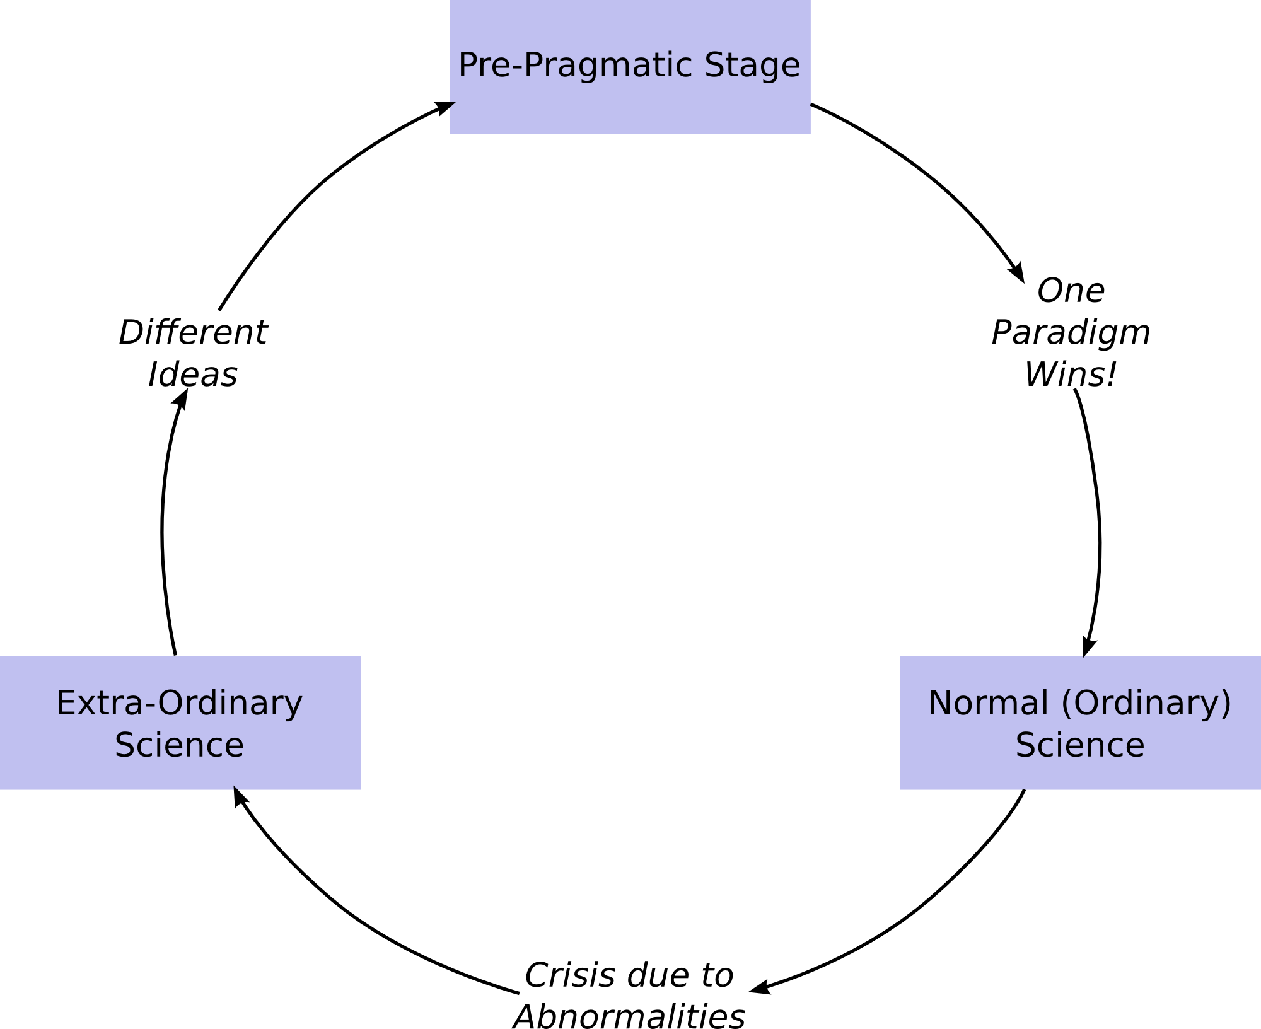
Figure 1.1. Revolution in Science
In pre-paradigmatic stage, there are a few ideas that compete with each other, and try to become a dominant (or alpha) idea. This is then labeled the alpha-paradigm. We may call this stage, the competition of paradigms in which the scientists are clustered behind their favorite paradigm, as the process tries to pick one of the paradigms. It was stated that this thesis aims to develop understanding and insights. Actually, it might be more appropriate to say that we wish to work on something other than normal science. The pursuit of extraordinary science, by definition, is not possible by a checklist or through an established technique. For this would mean there is already a paradigm to conduct extraordinary science, which logically is a contradiction. As an alternative to extraordinary science, however, academic research may be oriented to investigate and question the dominant paradigms.
In normal science, the scientists operate within the guidelines of the winning paradigm, find its limits and try to extend its potential. As time passes, and even though the community has some problems with the dominant paradigm, trust of, and a familiarity to the dominant paradigm develops over the years. Often, the community is blinded and does not accept the paradigm's shortcomings, or is afraid of what might happen after letting go of the dominant paradigm. This is called “Paradigm Paralysis”. It is very hard at this point to accept that the existing paradigm is not adequate, to break the chains for a new paradigm, and make a leap. But eventually the paradigm causes a crisis in the scientific community, and this leads us to the next phase of the science, that is, what Kuhn names “Extraordinary Science”.
At this stage, to answer all those unanswered questions, a scientific revolution is needed. Creating a new paradigm, a methodology, requires more work and patience compared to normal science. Kuhn's idea of a revolution in science has significant philosophical ramifications. From the beginning of the 20th century, the beginning of the logical positivism, it was well accepted that science is a cumulative progress. But according to Kuhn, science is not cumulative, and we need to make a leap to make a progress. A crucial fact of extraordinary science, according to Kuhn, is that different scientific paradigms are incommensurable. If two scientists from different paradigms try to find a new method on the same subject, they cannot compare their work to each other. Their experiments and observations depend on the observer, thus one's work may seem irrational or irrelevant to the other one. In this stage, new proposed methodologies are conducted and proposed to the community and we get back into the pre-paradigmatic stage.
We cannot say whether ordinary or extra-ordinary sciences is better. Because these two phenomena are interconnected. They are co-dependent in a cyclical self-triggering fashion. Only together as a whole, one can speak of science. But the question is, since science depends on the paradigm of the experimenter or observer, is progress in science is arbitrary?
It was stated that this thesis aims to develop understanding and insights. Actually, it might be more appropriate to say that we wish to work on something other than normal science. The pursuit of extraordinary science, by definition, is not possible by a checklist or through an established technique. For this would mean there is already a paradigm to conduct extraordinary science, which logically is a contradiction. As an alternative to extraordinary science, however, academic research may be oriented to investigate and question the dominant paradigms. The hope is that such investigation may lead to extraordinary science, or at least bring about deeper understanding, either reinforcing or eroding the dominant paradigm. Parenthetically, let us also divulge why we want to work outside the dominant paradigm. The survey of the greater literature in philosophy of engineering, philosophy of science leads to the question of the role of an engineer in academia (Engineering, 2010). A case in point, if the role of an engineer is to apply science, why is so much academic engineering research oriented towards basic research, arguably void of any hope for application or implementation? There are numerous articles that claim that studies in academia are irrelevant to the extent that they cannot be applied in real world (Anonymous Academic, 2014; Panda & Gupta, 2014; Boehm, 1980; Economist, 2010; Excell, 2013).
We have to state that this study is not exactly Extraordinary Science. However, we do not have any references to create a checklist to get results. This study focuses on the simulation in production lines and queues. Literature review on production lines and paradoxes are given as a subsection in Chapter 1. The scope of the thesis is explained in Chapter 2. Analysis in M/M/1 Queue and Production Line are given in Chapter 3, and Chapter 4, respectively. Lastly, Conclusion and Future Studies is given in Chapter 5.

Critical Thinking and Its Contextual Relationship with Paradoxes
Science and technology are what they are now due to the scientists and academicians, who have been skeptical within a rigorous framework of critical thinking. Costa (1985) gathered different definitions of critical thinking from different works. Critical thinking might be defined as thinking which achieves a rational conclusion using adequate information by analyzing, observation, evaluation, or explanation. The Critical Thinking Community (The Critical Thinking, n.d.) also has a definition which is widely accepted. They define critical thinking to be “the intellectually disciplined process of actively and skillfully conceptualizing, applying, analyzing, synthesizing, or evaluating information gathered from, or generated by, observation, experience, reflection, reasoning, or communication, as a guide to belief and action” (The Critical Thinking, n.d.).
According to Paul (1991), there are three groups of mental structures to be considered as an open-minded thinker. The first one is micro-level skills by which one distinguishes a sub sentence, a skeptical assumption, or inconsistency. At the macro-level, there are skills by which one makes contributions to discussions, creates theories, and knows how to approach a subject critically. The third group of essential skills to critical thinking contains the aspects of mind such as intellectual virtues and moral commitments. Paul (1991) also gives a detailed table of the elements of critical thinking.
Further examples of critical thinking are given in Appendix 1.

Paradoxes
The word of “paradox” stems from Greek word “parádoxos” which its root based on “pará” (“beyond”) and “dóxa” (“expectation”) means contrary to expectation. Felkins (1995) states that the paradoxes may occur from our lack of understanding which may be caused by the inadequacies of our language. In most of the paradoxes, the conclusion is seemingly both true and false at the same time, and thus present unresolved contradictions. Since the paradoxes show us the flaws in our understanding and the way we think, contradiction is essential to paradoxes.
Paradoxes are also self-referenced and sometimes they include circularity. One of the most known paradox, “This sentence is a lie” is self-referenced. “A goes to B”, “B goes to A” are the basic circular paradoxes. However, paradoxes may be caused by false or prejudiced statements which may be come from generalizations.
Cantini (2007) wrote in detail the development of paradoxes and contemporary logic. Cucić (2009) also wrote the development of paradoxes and very well gathered notable classifications made by other researchers.
There are several types of paradoxes. The classification of paradoxes by Quine (1966) might be reckoned as a basis for other classifications. According to Quine, there are three types of paradoxes as described in the following sections.

Veridical Paradoxes
Veridical paradoxes are also known as Truth-Telling or Verification paradoxes. They lead us to a seemingly absurd conclusion, however when a new premise is included, it convinces us that the conclusion is valid. This type of paradoxes may occur in situations where the language we use, or our understanding thereof, is not adequately sufficient for the circumstances. We may need more information or a new point of view on these paradoxes. Quine gave these examples to explain veridical paradoxes:
The Frederic Paradox: In the opera named Pirates of Penzance, the character Frederic who works as an apprentice for the pirates, wants to leave because he wants to fell in love poetically. His friends in the ship fell badly about it, and do not want him to leave. On his 21st birthday, they tell him that he cannot leave the ship because in his contract, it is specified that he may leave at the age of 21, but he is currently only 5 years old, and that he has to remain with the pirates for 63 years. Even though it seems absurd at first, we can easily solve the paradox by saying that he was born in the leap year.
The Barber Paradox: Another example for veridical paradoxes that Quine gives is the so-called Barber Paradox. Here, there is a village barber who shaves all and only the men who cannot shave themselves. The first question comes to mind is that who shaves the barber. If the barber cannot shave himself, then the barber has to be shave himself. But, if he can, then he should not. There is an obvious circularity in this paradox. However, as stated earlier, such paradoxes can be viewed as an indication of our lack of understanding, or as inadequacies of our language. Thus, Quine's resolution of Barber Paradox might be the easy way out. After all, it is not stated if there is any other barber. If there is another barber in the village, then the second barber can shave our hero, thus the paradox unravels. But if there is no other barber in the village, we have no argument that only barbers can shave other men. By this we can conclude that arguments that create paradoxes might narrow our viewpoint.

Falsidical Paradoxes
Falsidical paradoxes are the ones that not only seem false, but are false. The conclusions established from the falsidical paradoxes are evidently absurd, but the arguments creating the paradoxes seem true. The causes that create the falsidical paradoxes are the hidden fallacies in the arguments. Most common falsidical paradoxes are the mis-proofs of algebra.
The 2=1 proof by Augustus De Morgan: Assume that X=1. If we multiply each side of the equation by X, we obtain X² = X. Then we subtract 1 from each side, we get, X²-1 = X-1. We extend the left side of the equation as, (X-1) (X+1) = X-1. If we simplify the equation by dividing each side by (X-1), we obtain, X+1 = 1. Since X=1, we get, 2 = 1. The conclusion is obviously wrong, even though we applied reasonable steps on the equation. However, what is not noticed is, X-1=0. Thus the fallacy in the argument is dividing the equation by X-1.
Achilles and the Tortoise: Another example that Quine gives is one of the Zeno Paradoxes, Achilles and the tortoise. As Silagadze writes (2005), Zeno claims that plurality, motion, and change are illusions, and established paradoxes categorized by these concepts. Achilles and the tortoise is one of the three paradoxes to defy that the motion is real. In this paradox, Achilles and the tortoise decides to make a footrace. Since the tortoise is really slow, Achilles gives him a head start. The paradox establishes a conclusion at this point, that the fast runner can never overtake the slow runner. Zeno says that where the fast runner gets after an interval of time, the slow runner will be further from that point. Thus the motion is just an illusion. However, what Zeno does not see is that Achilles will overtake the tortoise either in an infinite or a finite time. The resolution of this paradox and other Zeno Paradoxes are given by several works (Silagadze, 2005; Dowden, n.d.; Byrd, 2010).

Antinomies
Antinomies are the paradoxes that do not fit in these two categories above. They create a “crisis in thought” as Quine states (Quine, 1966). If one cannot find a fallacy in an argument, or cannot be convinced by the conclusion of the paradox, then these are called antinomies. The following examples are generally accepted as antinomies.
Grelling – Nelson Paradox: Before explaining the Grelling – Nelson Paradox (a.k.a. Grelling's Paradox), let us first define the adjectives “homological” and “heterological”. Homological is defined as “describing itself”. “English” is a homological word, since the word itself is English. “Word” is also homological, since the “word” is also a word. Heterological, on the other hand, is defined as “not describing itself”. “German” is a heterological word because it is not a German word. Long is also a heterological one since “long” it is not a long word, but a short, monosyllabic word.
What is paradoxical here is whether the word “heterological” is heterological or homological. The definition of heterological is “not describing itself”. Thus the word “heterological” should not describe itself. But it does, as all words have a meaning. Thus, we conclude that the word “heterological” is homological. However, if it is a homological word, heterological defines itself, and thus is a homological word. Thus there is a contradiction due to self-reference.
The Paradox of Epimenides: This paradox is very similar to Grelling's paradox. Epimenides was a Cretan who said “All Cretans are liars”. This is also a self-referencing paradox, which has the same structure as “This sentence is a lie”. If all Cretans really are liars, then the sentence of Epimenides is true. Therefore, he told the truth where the contradiction causes a paradox.
If we consider that some aspects of nature cannot be explained in any circumstance, antinomies are reasonable explanations of paradoxes. However, if we are pioneers in supporting that nature itself can always be explained but today's knowledge and experience are insufficient to explain, we can say that antimonies are also the paradoxes that would be resolved if more information were provided. Thus antinomies can also be considered as veridical or falsidical paradoxes. Furthermore, Quine (1966) states that “One man’s antinomy can be another man’s veridical paradox, and one man’s veridical paradox can be another man’s platitude”, meaning that defining the type of paradoxes is relative upon one's knowledge and experience.

Production Lines
Production lines are linear arrangements of workstations, where workstations display some type of randomness. Typically, the randomness may be due to random service times, or due to station breakdown. Often interstation buffers are employed to compensate for these sources of randomness. This makes the subsystem of each station with its preceding buffer look like a simple queueing system. Thus, production lines may also be regarded as tandem queues. This invites the generalization of tandem queues to queueing networks.
Production lines have received much attention in the industrial engineering and operations research literature. Starting from the mid-fifties, considerable work has been done in both understanding the fundamental mathematical structure of queueing networks, and in developing computational techniques to predict the performance of production lines. The latter concern underlies the justification of much of the simulation tools developed in the dawn of the computer age.
Analytical models for multi-station production lines, which are the focus of this research, are classified in two main categories. These categories depend on whether time is considered to be continuous or discrete. Discrete models are more suitable for paced assembly lines, often seen in automotive production. Modeling these systems is often done by continuous- time and discrete-time Markov models. Continuous-time models are favored in the process industry where no identification of the individual units exists, (e.g. chemical industries). In almost all cases, focus is on the evaluation of two primary performance measures: the production rate, and the expected number of items in the buffers. The studies of Schick and Gershwin (1978), Muth (1979), Muth and Yeralan (1981), and Gershwin and Schick (1983) are early examples of discrete -time Markovian models. Studies conducted by Yeralan et al. (1986), Yeralan and Tan (1997) provide examples of continuous-time models.
There are many extensions to these basic models. For instance, Maggio et al. (2009) present closed-loop systems. These may be considered as queueing networks. Such closed-loop systems are seen in industries where hot pallets are used to hold the work piece while it progresses through the manufacturing system. Once the work piece is completed, the hot pallets are returned to the beginning of the line. Thus, the models track the hot pallet.
There are several textbooks on the subject, to which the reader is referred for detailed information (Altiok, 1996; Askin & Standridge, 1993; Buzacott & Shanthikumar, 1993; S.B. Gershwin, 1994; Li & Meerkov, 2009; Papadopolous et.al., 1993; Tempelmeier & Kuhn, 1993).

CHAPTER 2
SIMULATION OF PRODUCTION AND SERVICE SYSTEMS
It is customary among those studies reported in the literature of stochastic models of production and service systems to find simulation runs that accompany any given analytical development. Simulation is most often used as a tool of verification. We do not question the basic premise that simulation may be used in this capacity. However, many models are developed in a brute force manner that the meaning of the very premise of a model becomes vulnerable to criticism. A recent report by Yeralan and Buyukdağlı (2015) mentions an automotive plant with 168 robotic workstations arranged in a serial manner. Even without inter-station buffers, given that each workstation is subject to breakdown, the system modeled as a discrete-time discrete space Markov chain has over 10⁵⁰ states. If we were to visit a different state every nanosecond, a complete tour of all the states would take 10²⁷ times the age of the universe. This is an incomprehensible number – so incomprehensible that Yeralan and Buyukdağlı (2015) calls into question the ontology of such a model.

The Paradox
We routinely see simulation models developed and used to analyze stochastic Markovian models of production and service systems. Given that there are an inordinate number of system states in typical Markovian models, how is it the case that simulation gives us answers which would take total enumeration a practically endless amount of time? We attempt to address and answer that very question in this thesis.

M/M/1 Queue
First, consider a system modeled as a continuous-time, discrete-state Markov process. We pick a system with the number of states even greater than the 10⁵⁰ mentioned for the automotive plant model. The continuous-time M/M/1 queue has a single server and an input queue. Customer arrive to the system with a rate of λ. Similarly, the service of a customer, provided that the system is not empty (and hence the server is not idle), is completed with rate μ. The number of customers in the system uniquely determines the state of the system. It is clear that the number of customers in the system is unbounded. Thus, the system state space is unbounded, with an infinite number of elements. A complete tour of all the states of the system is, by definition, impossible in a finite amount of time, irrespective of how quickly we visit each state.
In analyzing the M/M/1 queue, we often investigate two performance measures: the expected number of customers in the system, and the utilization of the server. The latter refers to the probability that the server is busy servicing a customer, or equivalently, that the system is not empty.
It is a relatively pedantic task to show that the system is stable if the arrival rate λ is less than the service rate μ. Or the ratio ρ=λ/μ, which is also referred to in the discipline as the traffic intensity, is less than unity. If the traffic intensity is greater than unity, then the system becomes unstable and the number of customers in the queue is expected to keep growing over time, never converging to a finite value.
Analytical work quickly reveals that if the traffic intensity is less than unity, then the expected number of customers in the system is 1/(1-ρ). Similarly, the server is busy with probability ρ and idle with probability (1-ρ) (Hillier and Lieberman, 2009).
We next build a simple simulation model for this infinite-state Markov process (see Appendix 2). A typical result from the simulation runs is given below (see Figure 2.1).
--- simulation parameters ---
Run time: 1000
Arrival rate: 9.00
Service rate: 10.00
Number of arrivals: 9023
--- simulated performance measures ---
Utilization: 0.89
Average number of customers: 7.76
Maximum number of customers: 54
--- computed performance measures ---
traffic_intensity: 0.90
ave_num_in_system: 9.00
Figure 2.1. Simulation Run Results
As seen, with a traffic intensity of 0.9, with a total of about 9000 transactions (9023 customers arriving), we obtain fairly good estimates for the performance measures. The utilization is found to be 0.89 (0.90 theoretical), and the average number of customers in the system was found to be 7.76 (theoretical 9.00).
Increasing the run time, and hence the number of transitions gives results even closer to the theoretical values. The graphs below (Figure 2.2) show how the estimated performance measures are affected by the runtime.
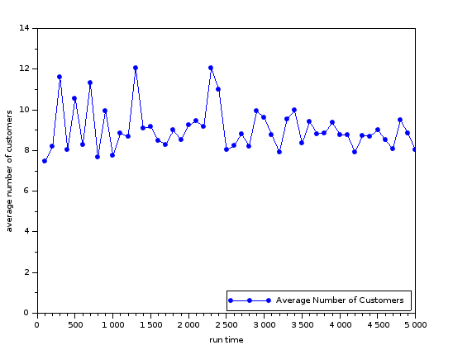
Figure 2.2. The Average Number of Customers in the System as a Function of the Simulation Runtime
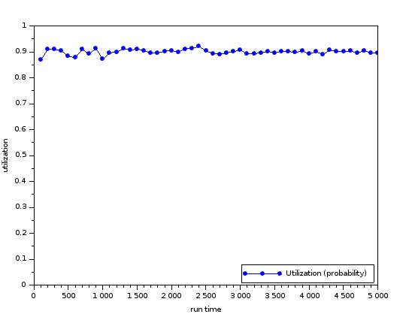
Figure 2.3. Server Utilization as a Function of the Simulation Runtime
Now, the question remains, as to how is it possible for a simulation run of only a few thousand transactions to yield performance measures so close to the theoretical values (relative errors in the range of a few percent), given that a total enumeration of the states is impossible. After all, the M/M/1 queue has an infinite number of states.
Since we run the simulation for a limited number of transactions (a limited amount of simulated time), it is clear that the simulation does not visit all possible states. We next inquire how many distinct states the simulation run actually visits.
Clearly, the M/M/1 queue may only make a transition to an adjacent state. That is, if there are N>0 customers in the system, the next transition would be to either state N+1 or to state N-1. Hence, the number of customers in the system throughout the simulation run is bounded by a maximum and minimum. It is customary to start the system at state 0 (empty system). Then the maximum number of customers in the system, N_{max}, during the simulation run is a finite number. Again, it is quite clear that N_{max} is a function of the simulation run. As the simulation run time increases, we may expect N_{max} to also grow, as there is more time for visiting states with a higher number of customers.
We modify the simulation code given in Appendix 2 and keep track of N_{max}. It is then plotted as a function of the runtime.
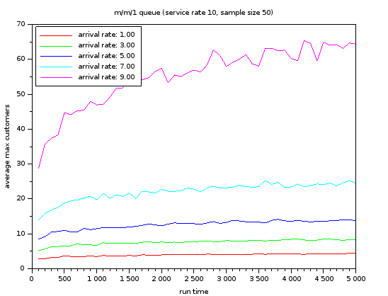
Figure 2.4. N_{max} as a Function of Runtime, as Obtained by Simulation
Figure 2.4 shows the results of the simulation runs. Each simulation run has a service rate of 10, and a runtime between 100 and 5000 time units. Five different arrival rates are used: 1, 3, 5, 7, and 9. The simulation was run and the maximum number of customers in the system (N_{max}) throughout the runs were recorded. Each point on the graph is actually an average of 50 runs with identical parameters. It is interesting to observe that, in each case, N_{max} quickly and asymptotically approaches a constant long-term value.
It is possible to analytically compute the expected value of N_{max} as a function of the system parameters and the length of time the system is observed. Such computation falls into the domain of transient analysis. Appendix 3 gives the transient analysis for an M/M/1 queue which starts with an idle server and runs for a given period of time. The analytical work shows how N_{max} may be computed. Here we will suffice with simply graphing the theoretical values of N_{max} (see Figure 2.5) and comparing them to the figure above.
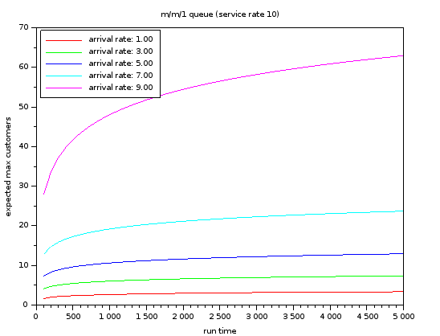
Figure 2.5. N_{max} as a Function of Runtime,
as Computed Theoretically
With a simulation runtime of 5000 time units, theoretically, the expected maximum number of customers in the system is about 65.

CHAPTER 3
MARKOVIAN MODELS OF PRODUCTION LINES
The preceding chapter provides insights into simulation as a modeling and computational tool. In particular, we find simulation to be useful in cases where the performance measures sought are, in some particular sense, commensurate with the general nature of simulation. It is clear that simulation is not a substitute for exact models, e.g. computing the steady-state probabilities of a Markovian model, when unusual performance measures are of interest.
In this chapter, we incorporate the insights gained into models of production lines. We aim to address and resolve the claim (Yeralan & Büyükdağlı, 2015) concerning the validity – in fact, the ontological standing – of Markovian production line models when the state space is simply telescoped by considering successive Cartesian products of the station states. Consider that, when there are about 100 stations, each station being in a state down or up, we have at least 2¹⁰⁰ system states. This is an unfathomably large number. No current simulation study can be expected to visit all of these states. However, we see from inspecting the M/M/1 queue that not all states need to be considered when seeking the usual performance measures.
In particular, almost all studies start with an investigation into the production rate of the line. The question is, parallel to the insights regarding the M/M/1 queue, is it reasonable to consider a truncated state space of the production line and obtain a good estimate to the production rate. After all, simulation is not expected to visit all such states, while its results are considered to constitute a benchmark. In order to address this question, we consider a minimalistic line, as we are interested in the fundamentals rather than any of the details. The investigation is constructed in the next section.

A Three Station Line with No Buffers
Consider a three-station production line with no buffers. The line is assumed to operate in discrete time, as explained in (ref MY81). There are five station states: up and operating (U), up but blocked (B), up but starved (S), down and under repair (D), down, blocked and under repair (X). With three stations and no buffers, the Markov chain has 32 states. These states are listed below (see Table 3.1).
Table 3.1. System States of the Production Line
Index | Station  States |  | Index | Station  States |  | Index | Station  States |  | Index | Station  States
0 | DDD |  | 8 | DSS |  | 16 | UUS |  | 24 | BDS
1 | DDU |  | 9 | DBD |  | 17 | USD |  | 25 | BBD
2 | DDS |  | 10 | DXD |  | 18 | USU |  | 26 | BXD
3 | DUD |  | 11 | UDD |  | 19 | USS |  | 27 | XDD
4 | DUU |  | 12 | UDU |  | 20 | UBD |  | 28 | XDU
5 | DUS |  | 13 | UDS |  | 21 | UXD |  | 29 | XDS
6 | DSD |  | 14 | UUD |  | 22 | BDD |  | 30 | XBD
7 | DSU |  | 15 | UUU |  | 23 | BDU |  | 31 | XXD

Having only 32 states, the Markov chain can be solved exactly for the given parameters. Given the station breakdown repair probabilities, we easily compute the steady-state probabilities. The production rate is obtained as the steady-state probability that the last station is in the state “up and operating”. In this case, there are eight such states, marked in bold in Table 3.1. Appendix 4 gives the C code that was used to compute the steady-state probabilities and the production rate.
An illustrative simple case is when we have identical stations, each with a breakdown probability of q and a repair probability of r. The production rate for such a production line is illustrated by the graphic below (see Figure 3.1).
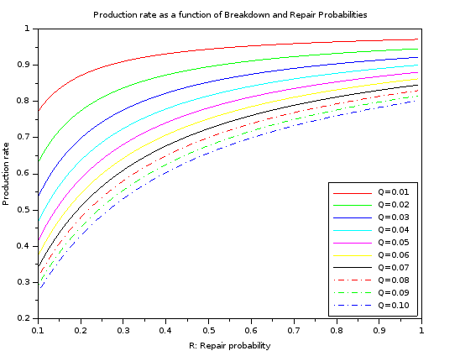
Figure 3.1. Production Rate as a Function of
Breakdown and Repair Probabilities
The insights into the why simulation works well for the M/M/1 queue led us to conclude that certain states are never visited. Only those states which are pertinent to the performance measures are visited. The performance of simulation, of course, also depends on the initial state. We next list explicitly the steady-state probabilities of each of the system states to see if there are any states with negligible effects on the performance measure. We select rather realistic parameters. A breakdown probability of 0.01 means that the mean time between failures is 100 cycles. The repair probability is selected to be an order of magnitude larger, corresponding to a mean time to repair of 10 cycles (see Table 3.2).
Table 3.2. Steady-State Probabilities of the Production Line Model (q=0.01, r=0.1)
Index | Station  States | Steady-State Probability |  | Index | Station  States | Steady-State Probability
15 | UUU | 0.74867172 |  | 2 | DDS | 0.00028882
25 | BBD | 0.07514296 |  | 5 | DUS | 0.00011103
24 | BDS | 0.06805575 |  | 14 | UUD | 0.00007917
8 | DSS | 0.06089789 |  | 28 | XDU | 0.00007585
16 | UUS | 0.01500090 |  | 1 | DDU | 0.00006823
4 | DUU | 0.00752210 |  | 20 | UBD | 0.00003962

Table 3.2 (cont’d). Steady-State Probabilities of the Production Line Model (q=0.01, r=0.1)
Index | Station  States | Steady-State Probability |  | Index | Station  States | Steady-State Probability
23 | BDU | 0.00752203 |  | 17 | USD | 0.00003574
19 | USS | 0.00676643 |  | 13 | UDS | 0.00003209
7 | DSU | 0.00676627 |  | 12 | UDU | 0.00000758
18 | USU | 0.00075181 |  | 31 | XXD | 0.00000280
30 | XBD | 0.00039688 |  | 10 | DXD | 0.00000252
26 | BXD | 0.00039618 |  | 27 | XDD | 0.00000228
22 | BDD | 0.00035895 |  | 0 | DDD | 0.00000204
9 | DBD | 0.00035656 |  | 3 | DUD | 0.00000065
29 | XDS | 0.00032296 |  | 21 | UXD | 0.00000028
6 | DSD | 0.00032170 |  | 11 | UDD | 0.00000023

The states are arranged so that their steady-state probabilities are in decreasing order. Again, we mark in bold those states where the last machine is productive. It is seen that the steady-state probabilities display a great range of values. The state with the largest probability is UUU with a probability of almost 0.75. The state with the least probability is UDD with a probability of 2.3x10⁻⁷. The difference between the largest and smallest steady-state probability is over six orders of magnitude. That is, the ratio is on the order of a million to one. Clearly, if a simulation runs shorter than a few million cycles, the state UDD with the smallest probability is likely never be visited. This is analogous to not visiting states with more than, say, 100 customers during the simulation of an M/M/1 queue with a traffic intensity of 0.9.

A Truncated Model of the Three Station Production Line with No Buffers
Inspired by our findings in Chapter 2 regarding the M/M/1 queue, now we consider a truncated model of the bufferless three-station line. We truncate the model by disregarding the states in which more than a single station is under repair. In effect, we are making the seemingly unrealistic assumption that once a station breaks down, the breakdown probability of the other stations is zero. This may seem unreasonable, but it does follow the truncated M/M/1 queue case. There, we make the assumption that once there are some K customers in the system, the arrival rate is zero.
The three-station case can easily be modified to find the production rate of the truncated model. One approach is to start with the steady-state probabilities as computed above. Then, we may remove those states with more than one station under repair, and re-normalize the steady-state vector. Afterwards, we re-compute the production rate.
The systems states with at most one station under repair are listed below (see Table 3.3).
Table 3.3. States with Fewer than Two Stations Under Repair
Number of Stations Under Repair | Index | Station States |  | Number of Stations Under Repair | Index | Station States
0 | 15 | UUU |  | 1 | 4 | DUU
 | 16 | UUS |  |  | 5 | DUS
 | 18 | USU |  |  | 7 | DSU
 | 19 | USS |  |  | 8 | DSS
 |  |  |  |  | 12 | UDU
 |  |  |  |  | 13 | UDS
 |  |  |  |  | 14 | UUD
 |  |  |  |  | 17 | USD
 |  |  |  |  | 20 | UBD
 |  |  |  |  | 22 | BDD
 |  |  |  |  | 23 | BDU
 |  |  |  |  | 24 | BDS
 |  |  |  |  | 25 | BBD
The state transition diagram illustrates the transitions among the systems states of the truncated model (see Figure 3.2).
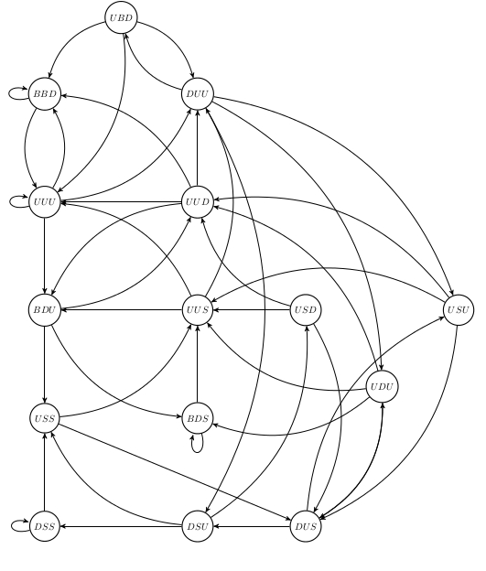
Figure 3.2. The State Transition Diagram of the Truncated Bufferless
Three Station Model
The states where the last station is operational are marked by bold letters. Note that of the eight such states, we now have only six. The normalization of the steady-state probabilities means we add the steady-state probabilities of the seventeen states shown in Table 3. and then normalize the vector by multiplying it with the reciprocal of the sum of its elements. The production rate is then computed as the sum of the normalized steady-state probabilities of the states shown in bold in Table 3.
The production rate of the truncated model will of course differ from that of the complete model. The question is by how much. We computed the difference for a series of parameters of a three-station bufferless line with identical stations. The differences are given as absolute percentage errors (APE). The absolute percentage error is computed as
$$absolutepercentageerror=100.\left|\frac{\left(productionrate-productionrateoftruncatedmodel\right)}{\left(productionrate\right)}\right|$$ | - ()
The absolute percentage errors are plotted below (see Figure 3.3).
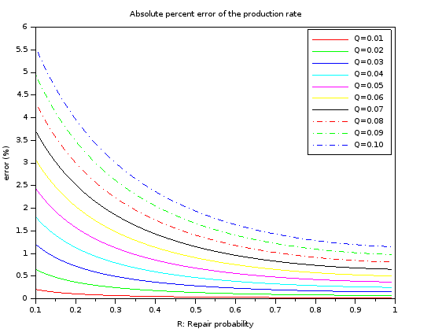
Figure 3.3. Absolute Percentage Errors as Functions of Model Parameters
Figure 3.3 is rather remarkable. First, observe that the maximum error is about 5.5%. This is actually an extreme case, where both the breakdown and the repair probabilities are 0.1. In this extreme case, the stand-alone availability of a station is 50%. Clearly, in actual implementations, a station would be expected to be operational more than 50% of the time. For realistic cases, that is, where the stand-alone availability is around 90%, the error less than 1%. This is a remarkable phenomenon, that serves not only as an eye-opener, but as motivation to develop practical approximate production line models which are then to be solved algebraically.

CHAPTER 4
CONCLUSIONS AND FUTURE RESEARCH
In summary, the prominent dominant industrial engineering paradigm in stochastic models of production and service systems calls for the development of various Markovian models whose validation is relegated to simulation studies. Propelled by a paradox that appeared in recent literature (Yeralan & Buyukdagli, 2015) we studied why such simulation gives acceptable results. Our work illustrates that in modeling such industrial engineering systems, there is an agreement between the performance measures and simulation. While other performance measures may not be easily obtained by simulation, measures such as the production rate and the expected number of in-process inventory are congruent to the simulation approach. The simulation community has recognized such shortcomings in general. For example, the topic known as Rare Event Simulation (Bucklew, 2004) dwells on events that have very little probability. However, such body of knowledge does not negate our efforts. It remains that whenever a Markovian model is to be validated by simulation, the applicability and validity of the simulation itself is to be questioned and tested. Again, the validation of simulation may require effort comparable to the validation of the Markov model by other (e.g. analytical) means.
The development of the previous chapters, provides a resolution to our paradox. Indeed, as in the M/M/1 case, simulation does not visit all possible system states. Rather simulation naturally focuses on the system states that have a greater influence on the performance measures. Removing the system states which have negligible effects on the performance measures, we were able to duplicate the results of simulation.
There are significant conclusions to this observation. First, simulation should not be seen as the ultimate verification tool. Its applicability and validity depend on how suitable simulation is to the particular performance measure of interest. For example, the simulation of an N-station production line will not be able to give an accurate estimate of the probability that all N stations are down, when N is large. In addition, in the numerical examples conducted, it was observed that simulation and exact solutions differ typically by a few percent. Such error ranges are prevalent in the literature. It calls into question that when a study compares its analytical results to simulation and reports errors of a few percent, it may well be that the error is due to simulation rather than the analytical models.

REFERENCES
Altiok, T. (1996). Performance Analysis of Manufacturing Systems. Springer.
Askin, R. G., & Standridge, C. R. (1993). Modeling and Analysis of Manufacturing Systems. Wiley.
Boehm, V. R. (1980). Research in the ‘Real World’ - A Conceptual Model. Personnel Psychology, 33(3), 495–503. https://doi.org/10.1111/j.1744-6570.1980.tb00479.x
Bucklew, J. A. (2004). Introduction to Rare Event Simulation. Springer.
Buzacott, J. A., & Shanthikumar, J. G. (1993). Stochastic Models of Manufacturing Systems. Prentice-Hall.
Byrd, D. (2010, June 10). Zenoʼs “Achilles and the Tortoise” Paradox and The Infinite Geometric Series.
http://homes.soic.indiana.edu/donbyrd/Teach/Math/Zeno+Footraces+InfiniteSeries.pdf
Cantini, A. (2007, October 16). Paradoxes and Contemporary Logic. http://plato.stanford.edu/entries/paradoxes-contemporary-logic/#Int
Costa, A. L. (1985). Developing Minds: A Resource Book for Teaching. In Costa A. L. (Ed.) Educational Leadership, ASCD.
Cucic, D. A. (2009, December 9). Types of Paradox in Physics. http://arxiv.org/abs/0912.1864\nhttp://www.arxiv.org/pdf/0912.1864.pdf
Dowden, B. (n.d.). Zeno’s Paradoxes. Retrieved December 8, 2009, from http://www.iep.utm.edu/zeno-par/
Economist. (2010). The Disposable Academic. Retrieved January 9, 2016, from http://www.economist.com/node/17723223
Eliason, J. L. (1996). Using Paradoxes to Teach Critical Thinking in Science. Journal of College Science Teaching, 15(5), 341–44.
Engineering, R. A. (2010). Philosophy of Engineering. Philosophy of Engineering: Proceedings of a Series of Seminars Held at The Royal Academy of Engineering, 1, 76.
Felkins, L. (1995, October 12). Paradoxes and Dilemmas. http://perspicuity.net/paradox/paradox.html
GCC (2016). Retrieved March 20, 2016, from https://gcc.gnu.org/.
Gershwin, S. B. (1994). Manufacturing Systems Engineering. Prentice-Hall.
Gershwin, S. B., & Schick, I. C. (1983). Modeling and Analysis of Three-Stage Transfer Lines with Unreliable Machines and Finite Buffers. Operations Research, 31(2), 354–380
Hansen, H. (2015, May 29). Fallacies. Stanford Encyclopedia of Philosophy. http://plato.stanford.edu/entries/fallacies/#ForAppInfFal
Hillier, F. S., & Lieberman, G. J. (2009). Introduction to Operations Research (9th ed.). McGraw-Hill Science
Excell, J. (2013). Academia’s Engineering Skills Shortage. Retrieved May 3, 2016, from https://www.theengineer.co.uk/issues/december-2013-online/academias-engineering-skills-shortage/
Kuhn, T. S. (1970). The Structure of Scientific Revolutions. University of Chicago Press.
Li, J., & Meerkov, S. M. (2008). Production systems engineering. Springer Science & Business Media.
Maggio, N., Matta, A., Gershwin, S. B., & Tolio, T. (2009). A decomposition approximation for three-machine closed-loop production systems with unreliable machines, finite buffers and a fixed population. IIE Transactions, 41(6), 562–574.
Muth, E. J. (1979). The Reversibility Property of Production Lines. Management Science, 25(2), 152–158. https://doi.org/10.1287/mnsc.25.2.152
Muth, E., & Yeralan, S. (1981). Effect of buffer size on productivity of work stations that are subject to breakdown. 20th IEEE Conference on Decision and Control including the Symposium on Adaptive Processes, 643–648.
Panda, A., & Gupta, R. K. (2014). Making academic research more relevant: A few suggestions. IIMB Management Review, 26(3), 156–169. https:// 10.1016/j.iimb.2014.07.008
Papadopolous, H. T., Heavey, C., & Browne, J. (1993). Queueing Theory in Manufacturing Systems Analysis and Design, Chapman & Hall/CRC.
Paul, R. W. (1991). Teaching Critical Thinking in Strong Sense. In Costa A. L. (Ed.), Developing Minds: A Resource Book for Teaching Thinking (Revised Ed, pp. 77 – 85). Alexandria, VA: ASCD.
Quine, W. (1966). The Ways of Paradox and Other Essays, W. V. Quine.
Schick, I. C., & Gershwin, S. (1978). Modelling and Analysis of Unreliable Transfer Lines with Finite Interstage Buffers, Electronics Systems Laboratory Report. ESL-FR-834-6, Massachusetts Institute of Technology 01239.
Silagadze, Z. K. (2005). Zeno meets modern science. Acta Physica Polonica B, 36(10), 2887–2929.
Tempelmeier, H., & Kuhn, H. (1993). Flexible Manufacturing Systems, Wiley-Interscience.
The Foundation for Critical Thinking. (n.d.). Defining Critical Thinking. Retrieved January 9, 2015, from https://www.criticalthinking.org/pages/defining-critical-thinking/766
The Guardian (2014, November 21). What Do Uni Engineering Departments Need Most? People in Overalls. http://www.theguardian.com/higher-education-network/2014/nov/21/university-engineering-departments-overalls-research
Yeralan, S., & Buyukdagli, O. (2015). The Ontology of Large-Scale Markovian models. Greece, SMMSO 2015 Conference, (p.2), University of Thessaly.
Yeralan, S., Franck, W. E., & Quasem, M. A. (1986). A continuous materials flow production line model with station breakdown. European Journal of Operational Research, 27(3), 289–300. https://doi.org/10.1016/0377-2217(86)90326-7
Yeralan, S., & Tan, B. (1997). Analysis of multistation production systems with limited buffer capacity part 1: The subsystem model. Mathematical and Computer Modelling, 25(7), 109–122. https://doi.org/10.1016/S0895-7177(97)00052-6

APPENDIX 1 – Critical Thinking
Critical thinking helps us to determine whether a given argument is valid or not. An argument is a set of premises (statements) that together comprise reason for a conclusion (another statement). This decision mechanism is based upon the logical and structural validity of the given statements, that is, whether the statements necessarily lead to the conclusion. When all of the premises are true, the conclusion must be true for the argument to be valid. For instance, your best friend told you that he cannot make it to the Broadway show tonight. When you asked him the reason, he might give these arguments: (a) that it is the end of the month and he ran out of money, (b) that he broke his arm, and it is casted or (c) that he just found out that the leading actress on the show is his ex-girlfriend.
The first argument seems possible to you, because you know it is the end of the month, and your friend does not know how to manage his money. It is a reasonably good argument which has nothing to do with morality, but directs us to a probable conclusion.
If your friend broke his arm, it is probably a good argument, which leads to a rational but not to an absolute conclusion. Even if it is true, your friend may take some pain killers and make it to the show if it is really important to you. Therefore, it is an ampliative argument.
And the lie that the beautiful, talented, leading actress on the show is your best friend's ex-girlfriend? It is a very, very bad argument obviously, because he is not that handsome, or wealthy, or clever. He is probably lying to you because he does not want you to know the real reason of why he cannot come. So why do you not be a good friend and treat him to the play by buying the tickets, or if he really broke his arm, pay him a visit with a bottle of red wine to make a movie night at home.
But sometimes, we can detect an incorrect conclusion from the arguments. Mistakes that we make unintentional or intentional (unfortunate but abundant examples can be seen in politics, or commercials, etc.) in critical thought is called fallacies. Dowden (n.d.) explains that there is an abundance of definitions for the term “fallacy”, since the researchers are picky and do not want to make a fallacy in its definition. There are two types of fallacies: formal fallacies and informal fallacies.
Formal fallacies are the ones which have invalid logical forms. Formal fallacies are illustrated by the fallowing example.
Premise 1: Industrial engineering graduates mostly work at production or service sectors.
Premise 2: Uncle Joe works in a production company.
Conclusion: Uncle Joe is an industrial engineering graduate.
This is an invalid conclusion since not everyone in the production sector is an industrial engineer. This invalid formal fallacy example also can be stated in a modus ponens format.
Premise 1: If X, then Y.
Premise 2: Y.
Conclusion: Therefore, X.
This type of fallacy is called a converse error. Besides formal fallacies, informal fallacies may also have mistaken in their forms, or contain mistakes in their content. Consider, for instance,
Premise 1: All Broadway show actresses only date handsome, clever, or wealthy men.
Premise 2: Your best friend is neither handsome, nor clever or wealthy.
Conclusion: Your best friend is lying about the Broadway actress being his ex-girlfriend.
Dowden (n.d.) also creates a list of fallacies which includes commonly used ones and their brief explanations. Hansen (2015) gives a background of fallacies and reviews the current topics in fallacy theory.
Paradoxes are similar to fallacies. Paradoxes are the cases in which we necessarily agree with the given arguments, but also disagree with its conclusion. This thesis focuses on such an issue. We discuss a seeming paradox in the field of Markovian production line models.
Agreeing with the argument but disagreeing with the conclusion could also be a visual paradox, as shown in Figure App.1.
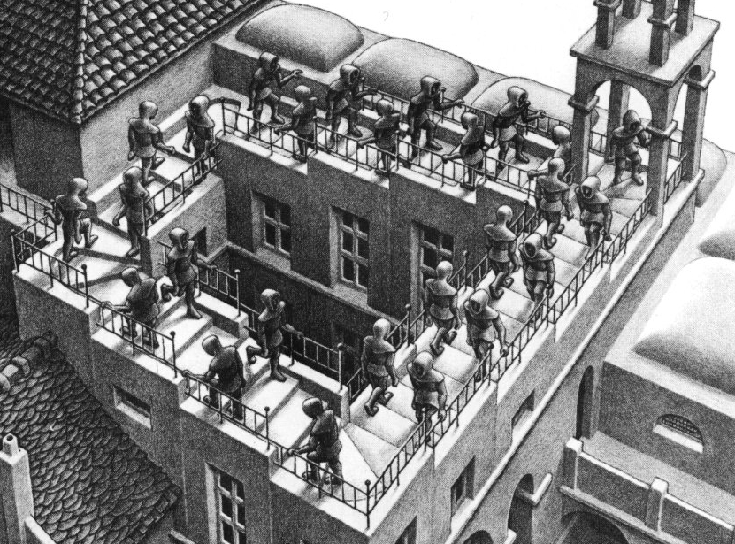
Figure A1.1. A Section of Ascending and Descending by Escher.
In the figure, are the men go up or down the stairs? The argument can be made that the men are going both up and down the stairs. While the arguments lead us to a valid conclusion, at the same time they lead us to an invalid one. According to Eliason (1996), paradoxes are invalid statements, but still have a value in critical thinking. He argues that since the paradoxes show that without giving sufficient thought, the arguments may lead us to a pitfall conclusion. Therefore, what we see, think, or understand is not exact, and sometimes multiple ideas are incompatible with each other.

APPENDIX 2 – M/M/1 Simulation in Scilab
A simple discrete-event simulation of the M/M/1 queue is implemented in Scilab (reference).
clc
clear

tRunTime=1000; // hours
rArrive = 9; // rate: arrival per hour
rService= 10; // rate: service completion per hour

// ------------------------------------------------------------
// generate arrival times and service (processing) times
arrivalTimes=[grand(1, 1, "exp", 1.0/rArrive)];
serviceTimes=[grand(1, 1, "exp", 1.0/rService)];

while (arrivalTimes($)<tRunTime),
// printf("%4d %8.4f %8.4f\n", length(arrivalTimes), arrivalTimes($), serviceTimes($));
arrivalTimes($+1)=arrivalTimes($)+grand(1, 1, "exp", 1.0/rArrive);
serviceTimes($+1)=grand(1, 1, "exp", 1.0/rService);
end
nTotalArrivals=length(arrivalTimes);

// generate service completion times
waitTime=0;
lastCompletionTime=0;
departureTimes=[];
for n=1:nTotalArrivals
waitTime=max(0, lastCompletionTime-arrivalTimes(n));
departureTimes(n)=arrivalTimes(n)+waitTime+serviceTimes(n);
lastCompletionTime=departureTimes(n);

// printf("%4d %8.4f %8.4f %8.4f %8.4f\n", n, arrivalTimes(n), serviceTimes(n), waitTime, departureTimes(n));
end

// run simulation collect data

nCustomers=0; // number of customers in the system
nMaxCustomers=0; // max number of customers in the system

tEmpty=0;
tCustomerTime=0;
indexArrive=1;
indexDepart=1;
time=0;
while (indexArrive<nTotalArrivals),
// printf("%4d %4d %4d %8.4f %8.4f %8.4f\n", indexArrive, indexDepart, nCustomers, arrivalTimes(indexArrive), serviceTimes(indexArrive), departureTimes(indexDepart));

if(arrivalTimes(indexArrive)<departureTimes(indexDepart)) then
// next event is an arrival
elapsedTime=arrivalTimes(indexArrive)-time;
if(nCustomers==0) then tEmpty=tEmpty+elapsedTime;
else
tCustomerTime=tCustomerTime+elapsedTime*nCustomers;
end;
nCustomers=nCustomers+1;
time=arrivalTimes(indexArrive);
indexArrive=indexArrive+1;
else
// next event is a departure
elapsedTime=departureTimes(indexDepart)-time;
tCustomerTime=tCustomerTime+elapsedTime*nCustomers;
nCustomers=nCustomers-1;
time=departureTimes(indexDepart);
indexDepart=indexDepart+1;
end
if(nCustomers>nMaxCustomers) then nMaxCustomers=nCustomers; end;:
end

fUtilization=1.0-(tEmpty/tRunTime);
fAveCustomers=tCustomerTime/tRunTime;

printf("--- simulation parameters ---\n");
printf("Run time: %8d\n", tRunTime);
printf("Arrival rate: %8.2f\n", rArrive);
printf("Service rate: %8.2f\n", rService);
printf("Number of arrivals: %8d\n\n", nTotalArrivals);

printf("--- simulated performance measures ---\n");
printf("Utilization: %8.2f\n", fUtilization);
printf("Average number of customers: %8.2f\n", fAveCustomers);
printf("Maximum number of customers: %8d\n\n", nMaxCustomers);

traffic_intensity=rArrive/rService;
ave_num_in_system=traffic_intensity/(1.0-traffic_intensity);

printf("--- computed performance measures ---\n");
printf("traffic_intensity: %8.2f\n", traffic_intensity);
printf("ave_num_in_system: %8.2f\n", ave_num_in_system);

APPENDIX 3 – The Maximum Length of the M/M/1 Queue
We consider the M/M/1 queue which starts from state 0 (empty system) at time 0 and runs for a given duration T. The number of customers in the system in the time interval [0, T] will vary as a function of the system parameters. We are interested in the distribution and the expected value of N_{max}(T), the maximum number of customers in the M/M/1 queue during the time interval [0, T], given that the system is empty at time 0.
The transition rate matrix of the M/M/1 queue with an arrival rate of λ and a service rate of μ is given below.
$$Λ=\left|\begin{matrix}-λ & λ & \\ μ & -\left(λ+μ\right) & λ \\ \begin{matrix} \\ \\ \end{matrix} & \begin{matrix}μ \\ \\ \end{matrix} & \begin{matrix}-\left(λ+μ\right) \\ ⋱ \\ \end{matrix}\end{matrix} \begin{matrix} & & \\ & & \\ \begin{matrix}λ \\ \\ \end{matrix} & \begin{matrix} \\ \\ λ\end{matrix} & \begin{matrix} \\ \\ -\left(λ+μ\right)\end{matrix}\end{matrix}\right|$$
Note that Λ is a square matrix of infinite size. The rows and columns of Λ correspond to the states. Specifically, element (j, k) of Λ is the transition rate from state j to state k, where j differs from k. The diagonal elements of Λ are set to -(λ+μ) so that the rows sum to zero. With this arrangement, the steady state probability row vector Π is computed as the normalized solution to the linear equation
$$ΠΛ=[0, 0, 0, …]$$
Normalization refers to setting the length of the vector Π so that its elements sum to unity. In vector notation, we may write,
$$Πu=1$$
where u is a column vector consisting of all ones as shown below.
$$u=\left|\begin{matrix}1 \\ 1 \\ \begin{matrix}1 \\ 1 \\ \begin{matrix}1 \\ 1\end{matrix}\end{matrix}\end{matrix}\right|$$
The transient solution is easily obtained for the general Markov process. Let Π(t) be the state row probability vector at time t. Then,
$$Π\left(t\right)= Π\left(0\right)e^{ΛΝt}$$
Given that the process starts in a state between 0 and N, the probability that the process stays with this range ([0, N]) is easily computed using the truncated state transition matrix. Let
$$Λ_{N}=\left|\begin{matrix}-λ & λ & \\ μ & -\left(λ+μ\right) & λ \\ \begin{matrix} \\ \\ \end{matrix} & \begin{matrix}μ \\ \\ \end{matrix} & \begin{matrix}-\left(λ+μ\right) \\ ⋱ \\ \end{matrix}\end{matrix} \begin{matrix} & & \\ & & \\ \begin{matrix}λ \\ \\ \end{matrix} & \begin{matrix} \\ \\ λ\end{matrix} & \begin{matrix} \\ \\ -\left(λ+μ\right)\end{matrix}\end{matrix}\right|$$
be a square matrix corresponding to the states 0 to N. Hence Λ_{N} has dimension N+1. Now the probability that the system is in state k where k is in the range [0, N] at time t is given as
$$Π\left(t\right)= Π\left(0\right)e^{ΛΝt}$$
In particular, let us assume that
$$Π\left(0\right)=Θ=\left[1,0,0,…\right].$$
Then, the probability that the system is still in the range [0, N] at time t, given that it started in state 0 at time 0 is given by
$Θe^{Λ_{N}t}u$,
where u is the column vector of ones as described above. This probability is the same as the probability that the state with the maximum index visited, N max is in the range [0, N]. In other words,
$P\left[N_{max}≤N\right]=Θe^{Λ_{N}t}u$.
which is the probability distribution function of the random variable N_{max}. Successive differences of the distribution function yield the probability mass function of N_{max}.

The production rate is also available as functions of the other station probabilities, however, such details are not the focus of our study. The reader is referred to the literature (see Gershwin, 1994) for these details.

